Prototype 1

Group 3

Ethan Butler, Tuyen Le, Ryan Mobley, Jason Tang, Justin Wade

Navigation:

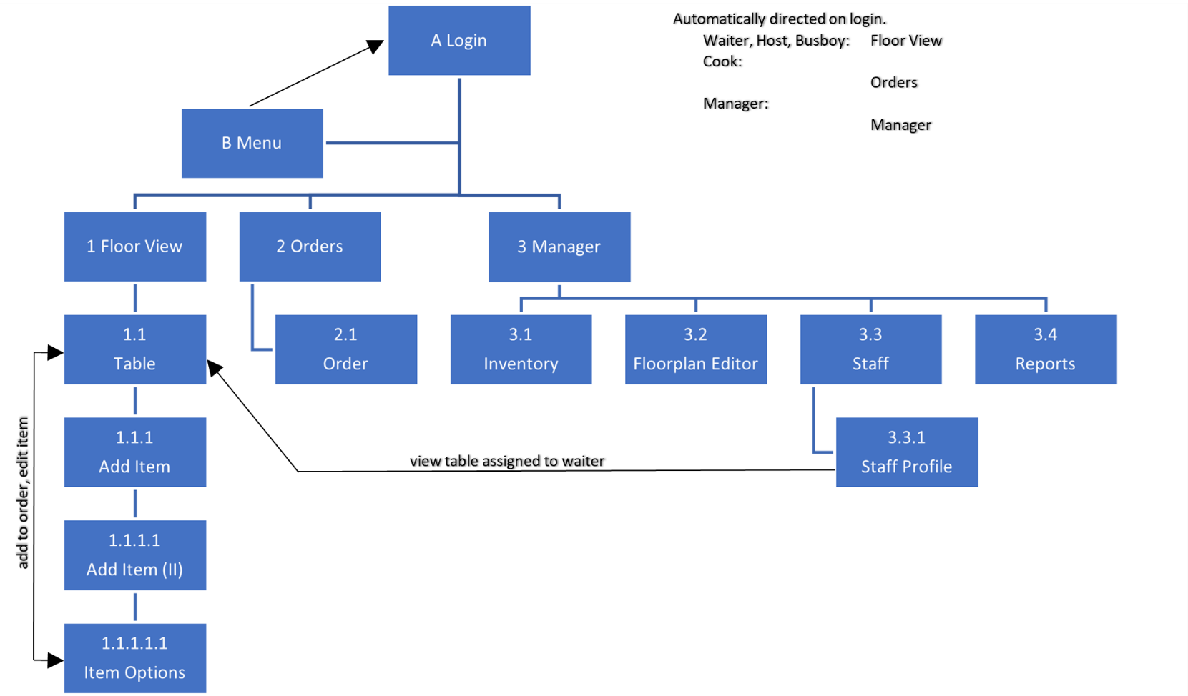

All directly linked pages have options to navigate between them. The menu is accessible from the button in the top-right corner in each screen. Available screens are automatically determined based on a user’s role.

A. Login

Login

0





2

1

3

5

4

6

8

7

9

077854

B. App Menu

Menu



Floor View



Orders



Manager



Logout



1 Floor View

Floor View

Assigned

Vacant

Dirty

Order(s) Prepared

**1**

**2**

**3**

**4**

**5**

**6**

**7**

**8**

**9**

**10**

**11**

**12**

**13**

**14**

**15**

**16**

Show Table Numbers

Note: “Show Table Numbers” is toggleable.

Navigation:

Clicking a Table => 1.1 Table

1.1 Table

Table #4

2 Burger $7.50 x 2

# American Cheese, Lettuce, Tomato, Medium Well

3 BLT $7.50 x 3

# American Cheese, Lettuce, Tomato, Medium Well

1 Monte Cristo $9.50 x 1

# Cheddar Cheese

Notes: Extra Napkins

Items Subtotal: $48.50

Tip: $7.00

Sales Tax: $3.00

Total: $58.50

1 Diet Coke $1.50 x 1

# No Ice

Edit

Edit

Edit

Edit

Pay

Add Item

Floor View



Notes:

* Show the current table’s tab/bill.
* The text in the “Notes” text box is editable.

Navigation:

Edit (an item) => 1.1.1.1.1 Item Options

Add Item => 1.1.1 Add Item (category)

Pay => [external page for payment processing]

1.1.1 Add Item (category)



Appetizers

Add Item



Salads



Meals



Kids Meals



Entrées



Sides



Drinks



Desserts

Table



1.1.1.1 Add Item (items within category)

Add Item

Burger $7.50

# Description

Entrées

BLT $7.50

# Description

Monte Cristo $9.50

# Description

Chicken Fingers $8.00

# Description

Ribeye Steak $16.50

# Description



Categories



Notes:

* Shows the items in the selected category (example: “Entrées”)
* The restaurant will provide the description for the relevant items.

Navigation:

[+] => 1.1.1.1.1 Item Options (Shown Below)

1.1.1.1.1 Item Options

Burger

Cheese $1.00

# American Cheddar Muenster

Lettuce



Tomato



Ketchup

Mayonnaise



Mustard



Add Item

Cancel

Avocado $2.00



Item Total: $8.50

Notes: Light Ketchup, Medium Well

Entrées



Notes:

* Item options can be added or removed. Some options (like cheese) may have radio buttons.
* The text in the “Notes” text box is editable
* Tapping a “plus” changes the icon into an “x” (example in this prototype: ketchup added)

Navigation:

Cancel => 1.1.1.1 Add Item (items within categories)

Add Item => 1.1 Table View

2 Orders

Navigation:

Orders

Order # X   
Status: Incomplete  
12:00:00 PM (time ordered)  
(Name of waiter here)

order # X   
Status: Incomplete  
12:00:00 PM (time ordered)  
(Name of waiter here)

order # X   
Status: Incomplete  
12:00:00 PM (time ordered)  
(Name of waiter here)

order # X   
Status: Incomplete  
12:00:00 PM (time ordered)  
(Name of waiter here)

1 x Sample Item  
2 x Sample Item  
1 x Sample Item   
 NO X ITEM  
1 x Sample Item

1 x Sample Item  
1 x Sample Item  
1 x Sample Item   
 EXTRA X ITEM  
1 x Sample Item

2 x Sample Item  
2 x Sample Item  
2 x Sample Item   
 EXTRA X ITEM  
1 x Sample Item

1 x Sample Item  
1 x Sample Item  
1 x Sample Item   
  
1 x Sample Item

order # X   
Status: Incomplete  
12:00:00 PM (time ordered)  
(Name of waiter here)

order # X   
Status: Incomplete  
12:00:00 PM (time ordered)  
(Name of waiter here)

1 x Sample Item  
1 x Sample Item  
1 x Sample Item   
  
1 x Sample Item

1 x Sample Item  
1 x Sample Item  
1 x Sample Item   
  
1 x Sample Item

Incomplete

Complete

Mark ready

Mark ready

Mark ready

Mark ready

Mark ready

Mark ready

Tap any order => 2.1 Order Detail Popup

2.1 Order Detail Popup

Orders

Order # X   
Status: Incomplete  
12:00:00 PM (time ordered)  
(Name of waiter here)

order # X   
Status: Incomplete  
12:00:00 PM (time ordered)  
(Name of waiter here)

order # X   
Status: Incomplete  
12:00:00 PM (time ordered)  
(Name of waiter here)

order # X   
Status: Incomplete  
12:00:00 PM (time ordered)  
(Name of waiter here)

1 x Sample Item  
2 x Sample Item  
1 x Sample Item   
 NO X ITEM  
1 x Sample Item

1 x Sample Item  
1 x Sample Item  
1 x Sample Item   
 EXTRA X ITEM  
1 x Sample Item

2 x Sample Item  
2 x Sample Item  
2 x Sample Item   
 EXTRA X ITEM  
1 x Sample Item

1 x Sample Item  
1 x Sample Item  
1 x Sample Item   
  
1 x Sample Item

order # X   
Status: Incomplete  
12:00:00 PM (time ordered)  
(Name of waiter here)

order # X   
Status: Incomplete  
12:00:00 PM (time ordered)  
(Name of waiter here)

1 x Sample Item  
1 x Sample Item  
1 x Sample Item   
  
1 x Sample Item

1 x Sample Item  
1 x Sample Item  
1 x Sample Item   
  
1 x Sample Item

Incomplete

Complete

Mark ready

Mark ready

Mark ready

Mark ready

Mark ready

Mark ready

Order # X

Status Incomplete

12:00:00 AM (Time ordered)

Items Item Changes

1 x Sample Item **NONE**  
2 x Sample Item **NONE**  
1 x Sample Item **NO X ITEM**

1 x Sample Item **NONE**

Mark Ready

Cancel



3 Manager

Manager



Floorplan Editor



Inventory



Employees



Reports

3.1 Inventory

Inventory

|  |  |  |  |  |  |
| --- | --- | --- | --- | --- | --- |
| **Item** | **Amount in stock** | **Amount need** | **To Purchase** | **Price Per Unit** | **Cost** |
| Salt (lb.) | 150 | 100 | 0 | $0.87 | %0.00 |
| Sugar (lb.) | 140 | 100 | 0 | $0.47 | %0.00 |
| Oil (gal) | 157 | 200 | 43 | $5.19 | $223.17 |
| Flour (lb.) | 50 | 100 | 50 | $0.22 | $11.00 |
| Beef (lb.) | 70 | 100 | 30 | $4.97 | $149.10 |
| Pork (lb.) | 74 | 100 | 26 | $2.77 | $72.02 |

Edit

Next page

Submit

Manager



3.2 Floorplan Editor

Floorplan Editor

# Renumber Tables

**1**

**2**

**3**

**4**

**5**

**6**

**7**

**8**

**9**

**10**

**11**

**12**

**13**

**14**

**15**

**16**

­

 Add Table

# Save Changes

# Cancel



Selected Table

Duplicate

Remove Table

Notes:

* Each table is selectable and can be moved/resized using the indicators.
* New tables are added by dragging the circle or rectangle icon under “Add Table”.
* The floorplan is automatically scaled between 3.2 Floorplan Editor and 1 Floor View.

Navigation:

Save Changes => Confirmation => 3 Manager

Cancel => Confirmation => 3 Manager

3.3 Staff

Staff

# Employee Name *Manager*

Employee Name *Host*

Employee Name *Host*

Employee Name *Waiter*

Employee Name *Manager*

Employee Name *Waiter*

Employee Name *Waiter*

Not Scheduled

# Employee Name *Host*

Employee Name *Waiter*

Employee Name *Waiter*

Employee Name *Busboy*

Employee Name *Manager*

Employee Name *Cook*

Employee Name *Cook*

# Add Employee

Current Shift

Manager



Navigation:

Clicking an Employee => 3.3.1 Staff Profile

Add Employee => 3.3.1 Staff Profile (editor view)

3.3.1 Staff Profile

Staff Profile

# Edit

# **Name**

**Phone Number**

**Email**

**Address**

**Hourly Rate ($)**

0.00

# **Role**

Employee Name

Waiter

404-444-4444

employeename@gmail.com

244 Place Road, Marietta, GA 30060

Active Tables

Shift Activity

Table #4 – added order

Table #7 – took payment

Table #6 – added order

Table #4

# Seated: 6:58 PM Status: Order Placed

Table #6

Seated: 6:41 PM Status: Order Placed

Table #7

Seated: 6:17 PM Status: Paid

Table #4 – assigned

**Notes**

Full-time, can’t work Tuesdays

**Authorizations**

none

Staff



Navigation:

Clicking a Table (under Active Tables) => 1.1 Table

Edit => (editor view, below)

Staff Profile

# Save Changes

# **Name**

**Phone Number**

**Email**

**Address**

**Notes**

Full-time, can’t work Tuesdays

# **Role**

Employee Name

Waiter

(404) 444-4444

employeename@gmail.com

244 Place Road, Marietta, GA 30060

Cancel

# **Delete Employee**



**Hourly Rate ($)**

0.00

# **Authorizations**

Issue Refunds

3.4 Reports

10/29/20 

Financial 

Reports

|  |  |  |  |
| --- | --- | --- | --- |
| **Time Period** | **Income** | **Expenses** | **Profit** |
| Daily  10/29/20 | $5,106.00 | $3,490.00 | $1,616.00 |
| Weekly  10/25/20 – 10/31/20 | $40,596.00 | $26,542.00 | $14,054.00 |
| Monthly  2020 October | $165,101.00 | $107,982.00 | $57,119.00 |
| Quarterly  2020 Q4 | $492,854.00 | $317,310.00 | $175,544.00 |
| Yearly  2020 | $1,987,652.00 | $1,236,885.00 | $750,767.00 |

Manager

